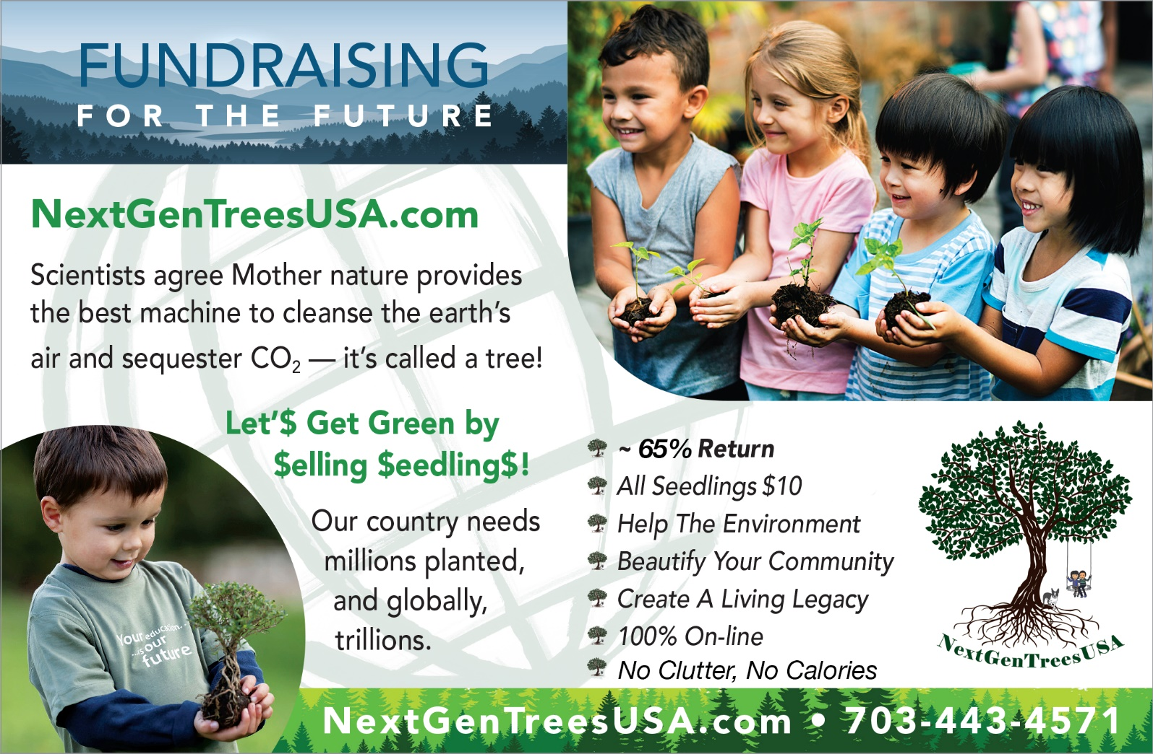

DID YOU KNOW, our fundraising program is all about helping kids, your school, and the planet by planting trees – lots of TREES! DID YOU KNOW, the best machine to cleanse the air and store CO₂ is in fact - a TREE. NGT is a NEW product-based fundraising program providing your school an outstanding ~65% return. Your students will offer baby tree seedlings to raise money for your school’s enrichment programs – and help the planet they’ll inherit.

NGT is LIVE for your 2022 Fundraising – Now Online

NGT provides a FRESH vision that powers up your fundraising campaign no matter your fundraising goal - $100k, $25k or other. NGT provides the support to help you achieve it! Your school keeps ~65% of every tree seedling bought by parents, families, and friends. A suggested price of $10 will energize your school’s fundraiser. Orders for your baby tree seedlings, from 8 to 36 inches tall, are delivered to your school in November - December (Fall fundraiser) or March - April (Spring fundraiser).

5 EASY STEPS TO A SUCCESSFUL FUNDRAISER

Step # 1 SAY “YES” TO SEEDLINGS: Respond via phone, e-mail, fax, NGT’s website, or carrier pigeon that you want to power up your fundraiser using tree seedlings with NGT.

Step # 2 SELECT SEEDLINGS: Fun! Select Your Fundraising Trees! NGT offers three categories of trees – Deciduous – Coniferous – Decorative. Critical to select no more than TWO tree species. Simplicity helps ensure success. NGT offers various native and non-native trees – none are invasive, and all the seedlings we ship to you are in their appropriate regional hardiness grow zone for your school.

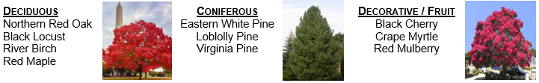
Step # 3 ADVERTISE SEEDLINGS: Easy! Your school will have its own unique online store. Let us know your seedling selections and NGT will send to you a corresponding social media tool kit. Use it to help market your fundraiser.

Step # 4 PURCHASE SEEDLINGS: The PTA/PTO has no upfront costs because the students’ families, friends and neighbors purchase tree seedlings from NGT. The students offer the baby trees for $10. At the conclusion of your campaign NGT will promptly send your proceeds to you.

Step # 5 DISTRIBUTE SEEDLINGS: The delivery and dissemination of your seedlings will occur in late November – early December for Fall fundraisers and March - April for Spring fundraisers for Spring planting. The Fundraising Guide outlines a best practice for distributing the seedlings.

What’s Next? When you say YES and tell NGT your seedling selections, NGT will send to you a comprehensive Fundraising Guide, customizable marketing pieces, a social media tool kit, and a Memorandum of Understanding.

Pricing for Your Tree Seedlings

Tree seedlings cost $3.50 each, and $10 is the suggested donor’s sale price, providing you with an ~65% return. THERE ARE NO UPFRONT COSTS (i.e. no prefunding of the seedlings). NGT will handle the packaging of the Parent Pick-Up bags for you for each family for dissemination. [Contact NGT for exceptions to the two species limit.]

NextGenTreesUSA charges a fee for the shipping and handling of the tree seedlings. There is a base fee of $25 for the first 100 seedlings plus an additional $10 charge for each additional 100 seedlings (or fraction of 100). There is also a nominal processing fee for credit card transactions. NOTE: If your PTA/PTO organization has a Resale Tax Exemption Certificate issued by your state, NGT needs a copy of it.

Please Fill in the Information Requested Below

Use This Link https://nextgentreesusa.com/pta-pto-summary or the QR Code to Access an Online Version
School Name: |  |  |  | #Students:
District/Co. |  |  | Fundraising Goal:
Address: | City: | State: |  |  |  | ZIP:
Principal | Email: |  |  |  | Phone:
Assistant’s Name: | Email: |  |  |  | Phone:
PTA/PTO Contact (List key contact first)
Name: | Email |  |  |  | Phone:
Name: | Email: |  |  |  | Phone:
Name: | Email: |  |  |  | Phone:

Thank you! We would be delighted to work for you, helping to make this year your best fundraising year – ever!

NextGenTreesUSA.com
Trees4Kids@NextGenTreesUSA.com
o: 703-443-4571
f: 804-773-8070

